CIVIL HARDWARE SHOP MANAGEMENT

TEAM MEMBERS:
1. Tanmay Degloorkar (1112)(GL)
2. Abhishek Ambre (1102)
3. Alok Sethiya (1144)
4. Parag Shrikhande (1160)

PROJECT GUIDE:
Mrs. Darshana Yadav

Index

Sr. No. | Description | Page No.
1 | Project Scope
2 | Project Requirements
3 | Entity Relationship Diagram
4 | Table Design with Normalization
5 | Queries

SCOPE

1. Cash Credit A/C generation:
a. Cash credit a/c already generated in bank.
b. As per the requirements purchase order is placed to the whole seller and from the bill amount generated, the loan gets sanctioned from the bank.

2. Placing purchase order to supplier:
It includes required item specification & the quantity.

3. Delivery challan:
On the placed order delivery challan is handed over upon delivery of the product.

4. Material inward checking:
As soon as material is received along with the delivery challan the materials are crossed checked with the item mentioned in purchased order.

5. Payment process:
Upon the delivery of the products the delivery challan is submitted to the bank & the required loan amount is sanctioned.
When the amount is received from the bank the payment is forwarded to whole seller.
6. Customer Bill:
On the order placed by customer the specific products are delivered to customer & the bill is generated. This process is done in cash.
1. Placing order to supplier.
2. Stock Recording:
The recording or maintenance of the stock is done when the products are bought from whole seller and sold to customer.
3. Discount policies:
i. Discount of 10% when any item quantity is more than 50.
ii. Discount of 20% when any item quantity is more than 100.

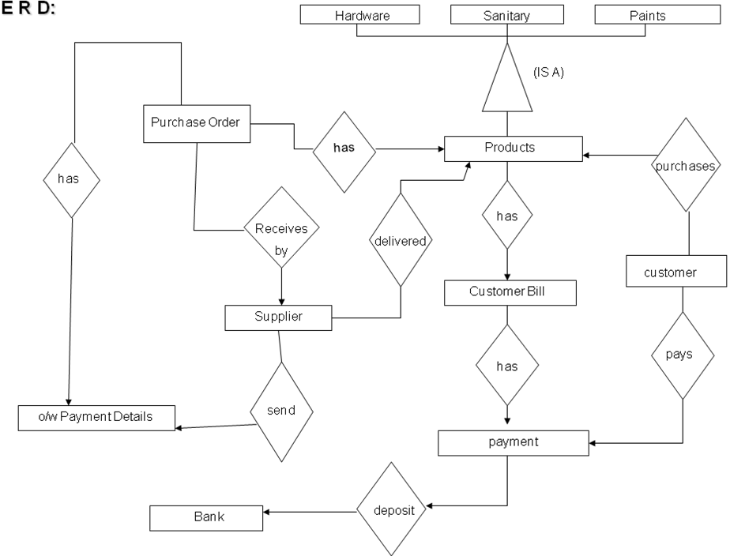

Unnormalized Data
Serial Number | Column Name
1 | S_no
2 | S_name
3 | S_city
4 | Address
5 | Contact No
6 | Email
7 | Pro_no
8 | Pro_name
9 | Pro_unit
10 | Pro_price
11 | A/C_no
12 | A/C_type
13 | A/C_balance
14 | Loan_no
15 | Bank Name
16 | Branch_No
17 | Loan_no
18 | Date_start
19 | Date_end
20 | Int_rate
21 | Loan_amt
22 | po_no
23 | Po_date
24 | S_no
25 | po_no
26 | Pro_No
27 | Quantity
28 | Price
29 | Amount
30 | Pur_inv_no
31 | P_invoice_date
32 | Po_no
33 | Payment_amt
34 | Payment_date
35 | Cheque_no
36 | Cheque_date
37 | Inword_no
38 | Pur_inv_no
39 | Pro_no
40 | Pro_name
41 | Quantity
42 | Pro_price
43 | Inword_date
44 | DC_no
45 | DC_date
46 | Stock_lot_no
47 | Lot_Date
48 | Stock_lot_no
49 | Pro_no
50 | Pro_name
51 | Quantity
52 | Price

NORMALIZATION

1 NF
All Fields in record should be atomic and single valued there are no repeating group of items.
REPEATING:
Prod_no
S_no
Loan_no
Po_no
Stock_lot_no

NON REPEATING:
Prod_name
Prod_unit
Prod_price
Prod_type
S_name
S_add
S_city
Prod_qty
Acc_no
Acc_type
Acc_bal
loan_start_date
loan_end_date
Loan_int_rate
Loan_amt
Bill_no
Bill_date
Cust_name
Quantity
Bill_amt
Po_date
Pot_qty
Pay_date
Pay_amt
Cheque_no
Cheque_date
Lot_date
Stock_qty

2NF
All non-key attributes should be fully functionally depend on entire primary key.
PRODUCT
Prod_no (PK)
Prod_name
Prod_type
Prod_unit
Prod_price
SUPPLIER
S_no (PK)
S_name
S_add
S_city

BANK
Acc_no (PK)
Acc_type
Acc_bal
Loan_no
Loan_start_date
Loan_end_date
Loan_int_date
Loan_amt

CUSTOMER BILL
Bill_no (PK)
Bill_date
Cust_name
Quantity
Bill_amt

Purchase order
Po_no (PK)
Po_date
Po_qty
Po_amt

Payment_details
Pay_date
Pay_amt
Cheque_no
Cheque_date
Po_no

STOCK
Stock_lot_no
Lot_date
Stock_qty

3NF
All non key attributes should not determine other non key attributes.
PRODUCT
Prod_no (PK)
Prod_name
Prod_type
Prod_unit
Prod_price
SUPPLIER
S_no (PK)
S_name
S_add
S_city

BANK
Ac_no (PK)
Ac_type
Ac_bal
Loan_no (FK)

LOAN
Loan_no (PK)
Loan_start_date
Loan_end_date
Loan_int_date
Loan_amt

CUSTOMER BILL
Bill_no (PK)
Bill_date
Cust_name

CUSTOMER_BILL_TRANS
Quantity
Bill_amt
Prod_no (FK)
Prod_name

Purchase order
Po_no (PK)
Po_date
S_no (FK)

Purchase_order_trans
Po_no(FK)
S_no(FK)
Prod_no(FK)
Po_qty
Po_amt

Payment_details
Pay_date
Pay_amt
Cheque_no
Cheque_date
Po_no (FK)

STOCK
Stock_lot_no(PK)
Lot_date

STOCK_TRANS
Stock_lot_no(FK)
Stock_qty
Prod_no (FK)
Pro_name

Table Designing
Master Tables:
Supplier Master
Sr. No. | Field Name | Field Data Type | Description
1 | S_no | Number | Primary key
2 | S_name | Text
3 | S_city | Text
4 | Address | Text
5 | Contact No | Number
6 | Email | Text

Product Master
Sr. No. | Field Name | Field Data Type | Description
1 | Pro_no | Number | Primary key
2 | Pro_name | Text
3 | Pro_unit | Text
4 | Pro_price | Number

Bank Master
Sr. No. | Field Name | Field Data Type | Description
1 | A/C_no | Number | Primary key
2 | A/C type | Text
3 | A/C balance | Number
4 | Loan_no | Number | Foreign key

Transaction Form
Loan Transaction
Sr. No. | Field Name | Field Data Type | Description
1 | Loan_no | Number | Primary key
2 | Date_start | Date/Time
3 | Date_end | Date/Time
4 | Int_rate | Number
5 | Loan_amt | Number

Purchase order MST
Sr. No. | Field Name | Field Data Type | Description
1 | po_no | Number | Primary key
2 | Po_date | Date/Time
3 | S_no | Number | Foreign Key (Supplier Master)

Purchase order Trans
Sr. No. | Field Name | Field Data Type | Description
1 | po_no | Number | Foreign key
2 | Prod_No | Number | Foreign key
3 | Quantity | Number
4 | Price | Currency
5 | Amount | Currency

Payment Details
Sr. No. | Field Name | Field Data Type | Description
1 | Pur_inv_no | Number
2 | P_invoice_date | Date/Time
3 | Po_no | Number | Foreign Key (Purchase Order)
4 | Payment_amt | Currency
5 | Payment_date | Date/Time
6 | Cheque_no | Number
7 | Cheque_date | Date/Time

Stock Mst.
Sr. No. | Field Name | Field Data Type | Description
1 | Stock_lot_no | Number | Primary key
2 | Lot_Date | Date and Time

Stock Trans.
Sr. No. | Field Name | Field Data Type | Description
1 | Stock_lot_no | Number | Foreign key
2 | Prod_no | Number | Foreign key
3 | Prod_name | Text
4 | Quantity | Number
5 | Price | Currency

TABLE CREATION
1.
create table bank
(
acc_no varchar2(15) primary key,
acc_type varchar2(20),
acc_bal number(20),
loan_no varchar2(10),
foreign key(loan_no) references loan(loan_no)
);

2.
create table customer_bill_trans
(
prod_name varchar2(20),
quantity varchar2(10),
bill_amt number(10),
prod_no varchar2(10),
bill_no varchar2(10),
foreign key(prod_no)
references product(prod_no),
foreign key(bill_no)
references customer_bill(bill_no)
);

3.
create table customer_bill
(
bill_no varchar2(10) primary key,
bill_date date,
cust_name varchar2(20)
);

4.
create table loan
(
loan_no varchar2(10) primary key,
loan_start_date date,
loan_end_date date,
loan_int_rate number(10),
loan_amt number(20)
);

5.
create table payment_details
(
pay_date date,
pay_amt varchar2(10),
pay_cheque_no varchar2(20),
pay_cheque_date date,
po_no varchar2(10),
foreign key(po_no)
references purchase_order(po_no)
);

6.
create table product
(
prod_no varchar2(10) primary key,
prod_name varchar2(20),
prod_unit varchar2(10),
prod_price number(10)
);

7.
create table purchase_order
(
po_no varchar2(10) primary key,
po_date date,
po_amt number(10),
s_no varchar2(10),
foreign key (s_no) references supplier(s_no)
);

8.
create table purchase_order_trans
(
po_no varchar2(10),
s_no varchar2(10),
prod_no varchar2(10),
pot_qty number(10),
foreign key(po_no)
references purchase_order(po_no),
foreign key(s_no)
references supplier(s_no),
foreign key(prod_no)
references product(prod_no)
);

9.
create table stock
(
stock_lot_no varchar2(5) primary key,
lot_date date
);

10.
create table stock_trans
(
stock_lot_no varchar2(5),
prod_no varchar2(10),
prod_name varchar2(20),
stock_qty number(10),
foreign key(stock_lot_no)
references stock(stock_lot_no),
foreign key(prod_no)
references product(prod_no)
);

11.
create table supplier
(
s_no varchar2(10) primary key,
s_name varchar2(30),
s_city varchar2(20),
s_add varchar2(10),
s_phne_no number(10),
s_email varchar2(20)
);

INSERT

1.
insert into bank values
(
'&acc_no',
'&acc_type',
&acc_bal,
'&loan_no'
);

2.
insert into customer_bill values
(
'&bill_no',
'&bill_date',
'&cust_name'
);

3.
insert into customer_bill_trans values
(
'&prod_name',
'&quantity',
&bill_amt,
'&prod_no',
'&bill_no'
);

4.
insert into loan values
(
'&loan_no',
'&loan_start_date',
'&loan_end_date',
&loan_int_rate,
&loan_amt
);

5.
insert into payment_details values
(
'&pay_date',
'&pay_amt',
'&pay_cheque_no',
'&pay_cheque_date',
'&po_no'
);

6.
insert into product values
(
'&pro_no',
'&prod_name',
'&prod_unit',
&prod_price
);

7.
insert into purchase_order_trans values
(
'&po_no',
'&s_no',
'&prod_no',
&pot_qty
);

8.
insert into purchase_order values
(
'&po_no',
'&po_date',
&po_amt,
'&s_no'
);

9.
insert into purchase_order_trans values
(
'&po_no',
'&s_no',
'&prod_no',
&pot_qty
);

10.
insert into stock values
(
'&stock_lot_no',
'&lot_date'
);

11.
insert into stock_trans values
(
'&stock_lot_no',
'&prod_no',
'&prod_name',
&stock_qty
);

12.
insert into supplier values
(
'&s_no',
'&s_name',
'&s_city',
'&s_add',
&s_phne_no,
'&s_email'
);

TABLES DISPLAY
SQL> select * from product;

PROD_NO PROD_NAME PROD_UNIT PROD_PRICE
---------- -------------------- ---------- ----------
10 nuts42 grm 75
11 nuts32 grm 85
12 pipes20 m 27
13 pipes42 m 40
14 handle kg 90
15 corners cm 45

6 rows selected.

SQL> select * from supplier;

S_NO S_NAME S_CITY S_ADD
---------- ------------------------------ -------------------- ----------
S_PHNE_NO S_EMAIL
---------- --------------------
1 m/s.praxis Pune SB Rd.
223987 praxis@rediffmail

2 m/s.sathe Pune MG Rd.
223421 sathe@rediffmail

SQL> select * from bank;

ACC_NO ACC_TYPE ACC_BAL LOAN_NO
--------------- -------------------- ---------- ----------
12345622 cash-credit 500000 123
12345624 current 250000 124

SQL> select * from loan;

LOAN_NO LOAN_STAR LOAN_END_ LOAN_INT_RATE LOAN_AMT
---------- --------- --------- ------------- ----------
123 12-MAR-12 12-MAR-13 12 500000
124 15-DEC-13 15-MAY-14 11 250000

SQL> select * from customer_bill;

BILL_NO BILL_DATE CUST_NAME
---------- --------- --------------------
151 12-MAR-12 Rakesh
152 12-MAR-12 Nikhil
153 13-MAR-12 Nilesh
154 13-MAR-12 Gaurav
155 15-MAR-12 nitin

SQL> select * from customer_bill_trans;

PROD_NAME QUANTITY BILL_AMT PROD_NO BILL_NO
-------------------- ---------- ---------- ---------- ----------
nuts42 10 750 10 151
handle 20 1800 14 151
corner 2 90 15 151

SQL> select * from purchase_order;

PO_NO PO_DATE PO_AMT S_NO
---------- --------- ---------- ----------
141 09-MAR-12 125000 1
142 09-JUN-12 35000 1
143 08-DEC-12 25000 2

SQL> select * from purchase_order_trans;

PO_NO S_NO PROD_NO POT_QTY
---------- ---------- ---------- ----------
141 1 10 120
142 2 10 130
142 2 11 140

SQL> select * from payment_details;

PAY_DATE PAY_AMT PAY_CHEQUE_NO PAY_CHEQU PO_NO
--------- ---------- -------------------- --------- ----------
12-MAR-12 1200 12345 12-MAR-12 142

SQL> select * from stock;

STOCK LOT_DATE
----- ---------
401 13-MAR-12
402 15-MAR-12
403 15-MAR-12
404 20-APR-12
405 12-MAY-12

SQL> select * from stock_trans;

STOCK PROD_NO PROD_NAME STOCK_QTY
----- ---------- -------------------- ----------
401 10 nuts42 1000
402 11 nuts32 5000
404 15 corners 10000
404 14 handle 7000

Queries

- Select all records from purchase order po date: 09-jan-2012.
SQL> select * from purchase_order_trans where po_no=(select po_no from purchase_order where
2 po_date='09-jun-2012');

- Select all records from loan of amount is 500000.
SQL> select * from bank where loan_no=(select loan_no from loan where
2 loan_amt=500000);

C. All details of customer where customer name is Rakesh
SQL> select * from customer_bill_trans where bill_no=(select bill_no from customer_bill
2 where cust_name='Rakesh');

D. Select all details of payment details where payment amount is
35000.
SQL> select * from payment_details where po_no=(select po_no from purchase_order
2 where po_amt=35000);

E. Select all suppliers from Pune.
SQL> select * from supplier where s_city='Pune';

F.Display all purchase order details where po_amt is greater than 25000.
SQL>select * from purchase_order where po_amt>25000;

G: Select bank details of a/c holder whose loan amount =500000.
SQL> select acc_no,acc_bal,loan_no from bank where loan_no=(select loan_no from loan where loan_amt=
500000);

H: Select customer name and bill amount.
SQL>select cust_name,bill_amt from customer_bill,customer_bill_trans where customer_bill.bill_no=customer_bill_trans.bill_no;

I: Display all product details from customer bill where bill amount=90.
SQL>select * from product where prod_no=(select prod_no from customer_bill_trans where bill_amt=90);

I: Display pay_cheque and purchase order date.
SQL>select pay_cheque_date,po_date from payment_details,purchase_order where payment_details.po_no=purchase_order.po_no;
J: Display payment amount and purchase order amount.
SQL> select pay_amt,po_amt from payment_details,purchase_order where payment_details.po_no=purchase_
order.po_no;

K: Display all details from stock transaction where stock lot no=401.
SQL> select * from stock_trans where stock_lot_no=(select stock_lot_no from stock where stock_lot_no
=401);

L: Display all customer bill details where bill amount between 500 and 2000.
SQL> select * from customer_bill_trans where bill_amt between 500 and 2000;

M: Display maximum bill amount from customer bill.
SQL> select max(bill_amt) from customer_bill_trans;

N: Display customer bill order by bill amount.
SQL> select * from customer_bill_trans order by bill_amt;

O: Display count of all product records.
SQL> select count(*) from product;

P: Display all records of product details in descending order.
SQL> select * from product order by prod_no desc;

Q: Display all stock records from date between 1-march to 30-april.
SQL> select * from stock where lot_date between '01-mar-2012' and '30-apr-2012';

R: Display all product name and their length.
SQL> select prod_name,length(prod_name) from product;

S: Display bill no and customer bill where bill not=154.
SQL> select bill_no,cust_name from customer_bill where bill_no not like '154';

T: Display purchase order details where amount is less than 100000.
SQL> select * from purchase_order where po_amt<100000;

U:display minimum purchase order amount.
SQL> select min(po_amt) from purchase_order;

V:display average of purchase order amount.
SQL> select avg(po_amt) from purchase_order;

W:display details of the product s costing between 27 and 50.
SQL> select * from product where prod_price between 27 and 50;

X:display product price and product name in descending order
SQL> select prod_price,prod_name from product order by prod_price desc;

Y:Display sum of all bill amounts where bill numbers are between 150 to 153.
SQL> select sum(bill_amt) from customer_bill_trans where bill_no between '150' and '153';

