COLLEGE
ADMISSION
System

- Team Strength : 4

- Team members :1) Dwarkesh Narvekar(1138)
2) Amit Magikar (1159)
3) Harish Rajarshi (1141)
4) Chetan jatkar (1122)

- Project Guide: Mrs. Darshana Yadav.



Index

Sr. No. | Description | Page No.
1 | Project Scope
2 | Project Requirements
3 | Entity Relationship Diagram
4 | Table Design with Normalization
5 | Queries

Project Scope

College admission System

The education is the process of instruction aimed at all round development of Individuals, providing the necessary tools and knowledge to understand and Participate in day to day activities of today’s world.
In the Context of rapid education and economic development, it is felt that the general education system is not adequate to meet the growing demands of the diversifying economy. Computers have brought up a revolutionary change in the past couple of decades.
College admission system is implemented to make the process easy for maintain admission details of the student .This system will have all the facilities like maintaining students details, granting admission to students, giving course details for the semesters, payments made by the students ,refund of the fees etc.
This system will be very advanced than the traditional admission system in which we will make automated data processing. In traditional system we had to do large amount of paper work and maintaining data was difficult. Data regarding course, students etc. Were written in separate register. And it was very difficult to refer all the registers when referring the data for use.
So in automated system all the data regarding the admission of the system is kept in one system only and it can be shared by many systems through the networks .
This system will be beneficial to manage information of thousands of students. The status of a student can be changed once admitted into the college. Student information such as id, address, contact number etc, can be maintained using the system.

Our system is designed in such a way that it can store all the information that the user needed for data processing and to generate various reports as per the requisition.
The major advantages of the proposed system over the manual system are as follows-

1.Time saving
2. Rapid information processing.
3. Accurate report generation.
4. Less manual work.
5. Fast and reliable system.

System features

Through this project we have attempted to create a simple yet very effective college Admission System.

The system was developed using Oracle 10g.

The process of college Admission system is as follows’:-

- The student takes the admission form for taking admission in the college.
- A student provides her personal information while taking the admission like her address, contact no, email, etc.
- Students also submit documents like domicile certificate ssc certificate etc.
- After admission is granted the students pays the prescribe fees for that course.
- After paying fees students get the receipt
- Student can also cancel his/her admission. And can take the refund back.
- Once a student has taken admission to the college he can avail facilities like common room, gym etc.

Project Requirements

Hardware:

Processor | i3
Ram | 4 GB
Hard Disk | 500 GB
OPERATING SYSTEM | Windows 7

Software:

Oracle 10g.

Entity Relationship Diagram
Sy_id
Sy_type
syllabus
First_name
Middle_name
Student_id
C_id
has
C_name
-name
Registers
C_id
Name
Last_name
DOB
Form_num
Course
Student
Isa
Course duration
E-Mail
Contact no
avails
Facility_id
C_id
MCA
MCM
Takes
Facilities
Facility type
Application _form
1
Form_num
Form_type
submits
Makes
Recives
has
Payment_type
Payment_no
Cancellation _id
Payment_amount
Payment _mode
Payment
Cancellation
Cancellation_date
Student_id
Caste
certificate
Student_id
Student_id
C_id
Doc_id
Reciept
has
Graduation
mark list

Migration certificate
Documents
Refund_no
Refund_date
Refund_amount
Receipt_no
Receipt_date
Ssc mark lsit
Hssc mark list
Cet score
Student_id
submits
Refund

m
Design with Normalization
UNNORMALISED DATA | CANCELLATION_DATE
STUDEND_ID | SY_ID
FIRST_NAME | SY_TYPE
MIDDLE_NAME | FACLILTIES_ID
LAST_NAME | FACILITIES_TYPE
CONATCT_NO
EMAIL_ID
ADDRESS
S_DOB
C_ID
C_NAME
C_DURATION
FORM_NUM
FORM_TYPE
PAYMENT_NO
PAYMENT_TYPE
PAYMENT_DATE
RECEIPT_NO
RECEIPT_DATE
DOC_ID
SSC CERTIFICATE
HSSC CERTIFICATE
MAIGRATION CERTIFICATE
CASTE CERTIFICATE
CET SCORE CARD
REFUND_ID
REFUND_AMOUNT
REFUND_DATE
CANCELLATION_ID

NON-REPEATING DATA | REPEATING DATA
STUDENT_ID | FIRST_NAME
CONTACT_NO | LAST_NAME
EMAIL-ID | MIDDLE_NAME
ADDRESS | C_NAME
C_ID | C_DURATION
FORM_NUM | S_DOB
PAYMENT_NO | FORM_TYPE
RECEIPT_NO | PAYMENT_TYPE
DOC_ID | PAYMENT_DAE
CANCELLATION_ID | RECEIPT_DATE
SY_ID | REFUND_AMOUNT
FACILITIES_ID | REFUND_DATE
FACILITIES_TYPE | CANCELLATION_DATE
SY_TYPE
1st Normal form

Repeating and non-Repeating Data must be separated
2Nd NORMAL FORM

Second Normal Form, every non-key field must depend on the entire primary key.

STUDENT:
STUDENT_ID (PRIMARY KEY)
FIRST_NAME
MIDDLE_NAME
LAST_NAME
CONTACT_NO
ADDRESS

S_DOB

COURSE:
C_ID(PRIMARY KEY)
C_NAME
C_DURATION

APPLICATION_FORM:
FORM_NUM(PRIMARY KEY)
FORM_TYPE

PAYMENT:

PAYMENT_ID(PRIMARY KEY)
AMOUNT
PAYMENT_DATE
PAYMENT_MODE

REFUND:
REFUND_ID(PRIMARY KEY)
AMOUNT
REFUND_DATE

CANCELLATION:

CANCELLATION_ID(PRIMARY KEY)
CANCELLATION_DATE

RECIEPT:

RECIPT_ID(PRIMARY KEY)
REECEPT_DATE

FACILITIES:
FACILITIES_ID(PRIMARY KEY)
FACILITIES_TYPE

SYLLABUS:
SY_ID(PRIMARY KEY)
SY_PATTERN

DOCUMENTS:
DOC_ID(PRIMARY KEY)
SSC CERTIFICATE
HSSC CERTIFICATE
DOMICILE CERTIFICAE
MIGRATION CERTIFICATE
CASTE CERTIFICATE
SCORE CARD

3rd Normal Form

All non key attributes should be fully functionally dependent on entire primary key.

STUDENT
STUDENT_ID (PRIMARY KEY)
FIRST_NAME
MIDDLE_NAME
LAST_NAME
CONTACT_NO
ADDRESS

S_DOB
FORM_NUM(FOREIGN KEY)
C_ID(FOREIGN KEY)

COURSE:
C_ID(PRIMARY KEY)
C_NAME
C_DURATION

APPLICATION_FORM:
FORM_NUM(PRIMARY KEY)
FORM_TYPE

PAYMENT:

PAYMENT_ID(PRIMARY KEY)
AMOUNT
PAYMENT_DATE
PAYMENT_MODE
STUDENT_ID(FOREIGN KEY)

REFUND:
REFUND_ID(PRIMARY KEY)
AMOUNT
REFUND_DATE
STUDENT_ID

CANCELLATION:

CANCELLATION_ID(PRIMARY KEY)
CANCELLATION_DATE
STUDENT_ID

RECIEPT:

RECIPT_ID(PRIMARY KEY)
REECEPT_DATE
STUDENT_ID

FACILITIES:
FACILITIES_ID(PRIMARY KEY)
FACILITIES_TYPE

SYLLABUS:
SY_ID(PRIMARY KEY)
SY_PATTERN
C_ID(FOREIGN KEY)

DOCUMENTS:
DOC_ID(PRIMARY KEY)
SSC CERTIFICATE
HSSC CERTIFICATE
DOMICILE CERTIFICAE
MIGRATION CERTIFICATE
CASTE CERTIFICATE
SCORE CARD
STUDENT_ID

Table schema

Students:
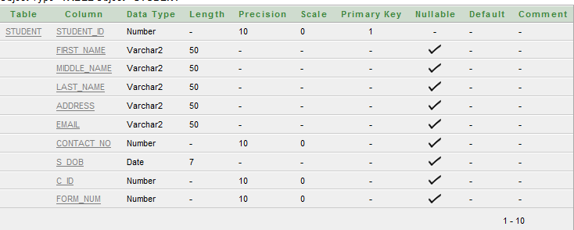

Course:
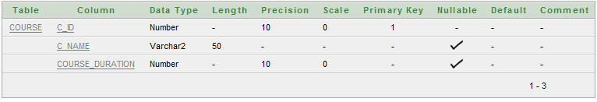

Application form:

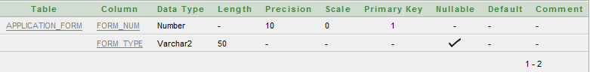

Payment:
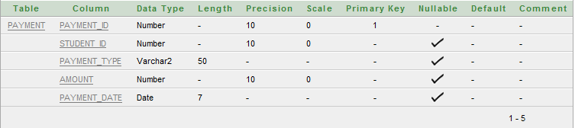

Reciept:
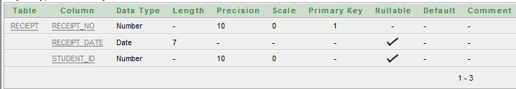

Refund:
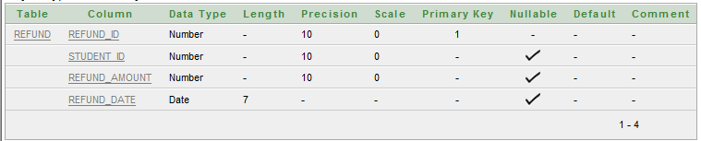

Cancellation:
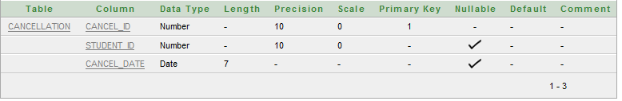

Documents:
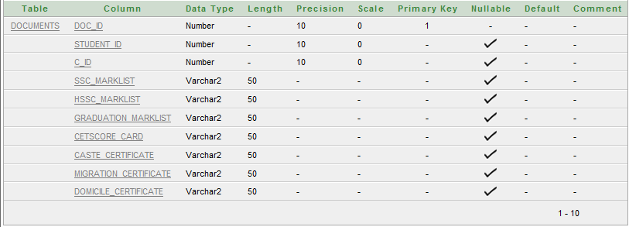

Facilities:
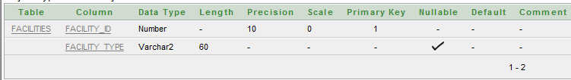

Syllabus:
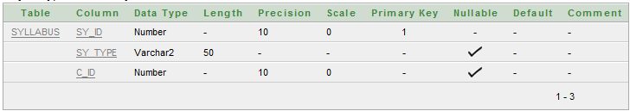

Queries

Creation of tables

Student:

create table student(student_id number(10),first_name varchar(50),middle_name varchar(50),last_name varchar(50),address varchar(50),email varchar(50),contact_no number(10),s_Dob date ,c_id number(10),form_num number(10),primary key(student_id),FOREIGN KEY(c_id) REFERENCES course(c_id),FOREIGN KEY(form_num) REFERENCES application_form(form_num))

Course

create table course(c_id number(10),c_name varchar(50),course_duration number(10),primary key(c_id))

Payment

create table payment(payment_id number(10),student_id number(10),payment_type varchar(50),amount number(10),payment_date date,primary key(payment_id),foreign key(student_id) references student(student_id))

Refund

create table refund(refund_id number(10),student_id number(10),refund_amount number(10),refund_date date,primary key(refund_id),foreign key(student_id)references student(student_id))

Receipt

create table reciept(receipt_no number(10), receipt_date date, student_id number(10), primary key(receipt_no), foreign key(student_id) references student(student_id))

Cancellation

create table cancellation(cancel_id number(10),student_id number(10),cancel_date date,primary key(cancel_id),foreign key(student_id)references student(student_id))

Documents

create table documents(doc_id number(10),student_id number(10),c_id number(10),ssc_marklist varchar(50),Hssc_marklist varchar(50),graduation_marklist varchar(50),Cetscore_card varchar(50),caste_certificate varchar(50),migration_certificate varchar(50),domicile_certificate varchar(50),primary key(doc_id),foreign key(student_id) REFERENCES student(student_id),foreign key(c_id) REFERENCES course(c_id))

Syllabus:

create table syllabus(sy_id number(10),sy_type varchar(50),c_id number(10),primary key(sy_id),foreign key(c_id) references course(c_id))

Facilities

create table facilities(facility_id number(10), facility_type varchar(60), primary key(facility_id))

Application form

create table appliaction_form(form_no number(10),form_type varchar(50),primary key(form_no))

insert query

Insert student

insert into student values(201,'Ram','ramesh','sharma','pune','ram@gmail.com',9923235667,'7-july-1990',101,501)
insert into student values(202,'Amit','d','Maggikar','pune','amit@gmail.com',9003245600,'8-oct-1990',102,502)
insert into student values(203,'vijay ','kumar','mishra','bihar','vijay@yahoo.com',9323035680,'7-july-1980',101,503)
insert into student values(204,'poonam','p','chattani','Amravati','poonam@rediffmail.com',9087235087,'20-nov-1989',102,504)
insert into student values(205,'Dwarkesh','M','Narvekar','Goa','Dwar@gmail.com',9923313057,'22-oct-1990',101,505)

Payment

insert into payment values (601,201,'cash',71000,'9-july-2011')
insert into payment values (602,202,'cheque',60000,'10-july-2011')
insert into payment values (603,203,'demand draf',71000,'11-july-2011')
insert into payment values (604,205,'demand draf',71000,'11-july-2011')

Reciept

insert into reciept values (701,'9-july-2011',201)
insert into reciept values (702,'10-july-2011',202)
Insert into reciept values (703,'11-july-2011',203)
Insert into reciept values (704,'11-july-2011',205)

Facilities

insert into facilities values(901,'common room')
insert into facilities values(902,'play ground')
insert into facilities values(903,'computer lab')
insert into facilities values(904,'gym')

Documents

insert into documents values (2001,201,101,'yes','yes','yes','no','not require','not require','yes')
insert into documents values (2002,202,102,'no','yes','yes','not require','not require','not require','yes')
insert into documents values (2003,203,101,'yes','yes','yes','yes','yes','not require','yes')
insert into documents values (2004,205,101,'yes','yes','yes','yes','not require','yes','yes')

Syllabus

insert into syllabus values(1001,'2008-2011',101)
insert into syllabus values(1002,'2005-2008',102)

Refund

insert into refund values(3001,201,65000,’22-jul-2011)
insert into refund values(3002,203,65000,’24-jul-2011)

cancellation

insert into cancellation values(801,204,’22-jul-2011)
insert into cancellation values(821,201,’22-jul-2011)
insert into cancellation values(803,203,’28-jul-2011)

application form

insert into application_form(501,’MCA’)
insert into application_form(502,’MCM’)
insert into application_form(503,’MCA’)
insert into application_form(504,’MCM’)
insert into application_form(505,’MCA’)

COURSE:

Insert into course values (102,’MCM,2)
Insert into course values (101,’MCA,3)

Select Query

1. Display all the details from table course
Select * from course

2. Display all details from table student
Select * from student

3. Display all details from table admission form
Select * from application_form

4. Display all details from table payment
Select * from payment

5. Display all details from table reciept
Select * from receipt

6. Display all details from table refund
Select * from refund

7. Display all details from table cancellation
Select * from cancellation

8. Display all details from table documents
Select * from documents

9. Dispaly the facilities details
Select * from facilities

10. Display the syllabus details
Select * from syllabus

Addition query

1. Display list of the entire student who has taken admission for MCA

Select first_name, middle_name, last_name from student, course where course.c_id=student.c_id and course.c_name='MCA'

2. Display the address of all the students.

Select distinct (address) from student

3. Display total fees paid by all the students

Select sum (amount) as total amount from payment

4.display total number of students who have taken admission to MCM.

Select count (student_id) as total students from student, course where course.c_name='MCM' and course.c_id=student.c_id

5. Display the list of all the student who have cancelled admission for MCA

Select student.student_id, first_name, Middle_name, last_name from cancellation, student, course where course.c_name='MCA' and cancellation.student_id=student.student_id

6. Display the entire student whose first name start with letter “V”

Select * from student where first_name like 'v%'

7. Display the student who has not submitted caste certificate
Select first_name, middle_name, last_name from student, documents where student.student_id=documents.student_id and documents.caste_certificate= 'no'

8. Display the details of the entire student who has not paid their fees
Select * from student
WHERE NOT EXISTS
(Select * from payment where student.student_id=payment.student_id)

9. Display the details of all the students whose admission has been cancelled but not got the refund
Select cancellation.student_id, student.* from cancellation, student
Where student.student_id=cancellation.student_id and NOT EXISTS
(Select first _name from refund,student where refund.student_id=cancellation.student_id)

10. Upadate the amount=65000 in table payment where payment id=602
Update payment set amount=65000 where payment_id=602

11. change the lower case letter from uppercase of students first name whose last name starts with letter “c”.
Select upper (first_name) As Name from student where last_name like'c%'

12. Display the amount groups in table payment

Select amount from payment GROUP BY amount

13. Display all the student details in descending order

SELECT * FROM student
ORDER BY first_name DESC

14. list all the students who have paid there fess (inner join).

SELECT student.student_id, student.first_name, payment. amount
FROM student
INNER JOIN payment
ON student.student_id=payment.student_id

15. List the details of all the students whose has paid and not paid fess (left join)

SELECT student.student_id, student.first_name, payment.amount
FROM student
LEFT JOIN payment
ON student.student_id=payment.student_id

16. Display student list between last name “chattani “and “Sharma”
-
Select * from student
Where last_name
between 'chattani' and 'sharma'

17. Find the length of first_name of the students
SELECT Length (first_name) as length_of_First_name FROM student

18. Display the student who last name are “Narvekar” and “Sharma”

SELECT * FROM student
WHERE last_name IN ('Narvekar','sharma')

19. Name all the students who have to submit the Migration certificates
Select student.student_id, first_name, middle_name, last_name from documents, student where student.student_id=documents.student_id and address NOT like '%Maharashtra%'

20. Display all the students and refund table (using UNION)

Select student_id from student
Union
Select student_id from refund

21. Display the names of the entire student who has received the receipt

Select first_name, middle_name, last_name from student,reciept where student.student_id=reciept.student_id

22. Display the list of student_id who have paid fees above 60000

Select student_id from payment group by student_id having sum (amount)>60000

23. Display the first 3 details of the student
SELECT *
FROM STUDENT
WHERE ROWNUM <=3

24. Delete from student where student id 201

Delete from student where student_id=201

25. Display the student has paid their fees (inner join)

SELECT student.first_name, payment.student_id
FROM student
INNER JOIN payment
ON student.student_id=payment.student_id
ORDER BY student.student_id

